**From:** Soukis, Spiro [mailto:Spiro.Soukis@crowncastle.com]   
**Sent:** Wednesday, April 1, 2020 11:20 AM  
**To:** Bigelow, Joe; Madani, Mo  
**Subject:** Updates to the TIA-222 for the 2020 code cycle

Good Morning Gentlemen,

I was hoping you could direct me in the proper way to submit a change proposal for updates to the TIA-222 Standard.  I am the Liaison to ICC for the TR14 Engineering Committee (responsible for the ANSI/TIA-222 Standard.

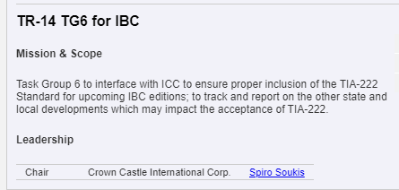

<http://standards.tiaonline.org/all-standards/committees/tr-14>

We’ve recently had the following issues slow the adoption process for the state amended versions of the 2018 IBC in New York State and New Jersey.  These were those issues:

2018 International Building Code from the link on the FloridaBuilding.org website: <http://media.iccsafe.org/floridareview>

**First:**

**SECTION 1609**

**WIND LOADS**

**1609.1 Applications.**  Buildings, structures and parts thereof

shall be designed to withstand the minimum wind loads pre-

scribed herein. Decreases in wind loads shall not be made for

the effect of shielding by other structures.

**1609.1.1 Determination of wind loads.**  Wind loads on

every building or structure shall be determined in accor-

dance with Chapters 26 to 30 of ASCE 7. The type of

opening protection required, the basic design wind speed,

V, and the exposure category for a site is permitted to be

determined in accordance with Section 1609 or ASCE 7.

Wind shall be assumed to come from any horizontal direc-

tion and wind pressures shall be assumed to act normal to

the surface considered.

**Exceptions:**

5.  Designs using TIA-222 for antenna-supporting

structures and antennas, **~~provided that the hori-~~**

**~~zontal extent of Topographic Category 2 escarp-~~**

**~~ments in Section 2.6.6.2 of TIA-222 shall be 16~~**

**~~times the height of the escarpment~~**.

The latter portion of Exception #5 is no longer valid. The requirement of Topographic Category 2 in Section 2.6.6.2 of TIA-222 is a reference to an older and outdated Revision, G-2005, of the TIA-222 Standard.  The latest Revision, H, does not contain this requirement in any Section within the TIA-222-H-2017.

**Second:**

SECTION 3108

TELECOMMUNICATION AND BROADCAST TOWERS

[BS] 3108.1 General. Towers shall be designed and con-

structed in accordance with the provisions of TIA-222.  **~~Tow-~~**

**~~ers shall be designed for seismic loads; exceptions related to~~**

**~~seismic design listed in Section 2.7.3 of TIA-222 shall not~~**

**~~apply.~~**~~In Section 2.6.6.2 of TIA 222, the horizontal extent of~~

~~Topographic Category 2, escarpments, shall be 16 times the~~

~~height of the escarpment.~~

As stated above, the Topographic Factor 2 portion is no longer valid. Also, the Seismic Design Exceptions per Section 2.7.3 of the TIA-222 is an old reference to the same outdated Revision, G-2005. The seismic design section of the TIA-222-H has been rewritten to align with ASCE 7; there are no conflicts between the two documents.

**Third and Most Importantly:**

CHAPTER 35

REFERENCED STANDARDS

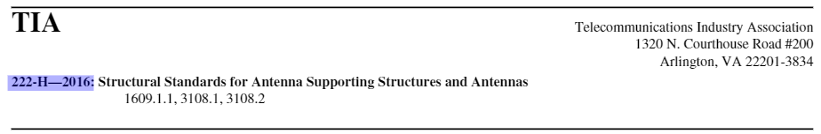

While the Revision, H, is correct, the year published should be 2017. Originally, we completed the Promulgator spreadsheet for the 2018 ICC Code Cycle with the reference above. However, due to delays in updating the Standard the published date was pushed to October 2017, well before the December 1. 2017 deadline for inclusion in the 2018 IBC.  Since the document referenced doesn’t actually exist, I would like to update the reference accordingly. I’ve attached the errata published by the ICC (p.1) and the approval from the State of NY for reference (p.12, highlighted text).

The reference should read as follows:

**TIA-222-H-2017 Structural Standard for Antenna Supporting Structures, Antennas and Small Wind Turbine Support Structures**

1609.1.1, 3108.1, 3108.2

I can include a copy of the TIA-222-H-2017 document on another email (doc is 10MB) if you would like a copy.  This is a limited copy provided for the ICC and other Governing Authorities.

**Thank you very much for your time in this matter** and please let me know how I should proceed to accomplish the changes above.

Sincerely,

**SPIRO SOUKIS**

Manager Engineering

T: (713) 570-3848 | M: (832) 656-7223

**CROWN CASTLE**

1220 Augusta Drive, Houston, TX 77057

<CrownCastle.com>

This email may contain confidential or privileged material. Use or disclosure of it by anyone other than the recipient is unauthorized. If you are not an intended recipient, please delete this email.

**TIA**

**Errata 2018 IBC Chapter 35 REFERENCED STANDARDS**

**Code/Standard:** 2018 International Building Code

**Applies to following Printings:** 1st printing

**Section/Table/Figure Number:** TIA

**Posted:** February 11, 2020

**Correction:**

**TIA**

**TIA-222-H-2016 2017 Structural Standard for Antenna Supporting Structures, and Antennas and Small Wind Turbine Support Structures**

1609.1.1, 3108.1, 3108.2

**Correlation Notes:** None